**Software Testing course**

**Lab. Report #0 – Introduction to Testing and Defect Tracking**

|  |  |
| --- | --- |
| Group number: |  |
| Student Names and ID numbers: | First Last (1234678) |
| First Last (87654321) |

**Table of Contents**

Full URL of your Zoho portal 2

1 Introduction (expected length ~ 300 words) 2

2 Defects (bugs) found in different test approaches, and filed in Zoho 3

2.1 Statistics and breakdown of defects (bugs) 3

2.2 Screenshot of defects 3

2.2.1 Screenshot of the “LIST” of ALL defects (need to have different “status” values) 3

2.2.2 Screenshots of five randomly-selected bug reports in Zoho, reported by student A 4

2.2.3 Screenshots of five randomly-selected bug reports in Zoho, reported by student B 5

3 Reporting from the exploratory testing 6

3.1 Exploratory testing plan 6

3.1.1 Exploratory testing plan, designed by student A 6

3.1.2 Exploratory testing plan, designed by student B 6

3.2 Your overall experience from exploratory testing 6

3.3 Peer reviews of defect reports and duplicate bug reports, after exploratory testing 6

3.3.1 Peer reviews, done by student A, on the defect reports submitted by student B 6

3.3.2 Peer reviews, done by student B, on the defect reports submitted by student A 6

3.3.3 Group’s learning and overall observation on peer-reviewing of bug reports 7

3.4 A brief discussion of duplicate bug reports 7

4 Manual scripted testing 7

5 Comparison of exploratory and manual-scripted functional testing in your lab work 7

5.1 Benefits (advantages) of each approach 7

5.2 Drawbacks (disadvantages) of each approach 7

5.3 Test effectiveness of each approach 7

5.4 Test efficiency of each approach 7

5.5 Trade-offs of the two approaches 7

6 Regression testing (verification of defect fixes) 7

7 Chain of software dependability threats: Error, defect, failure and incident 7

8 Seven fundamental principles of Software Testing in the context of this testing project 7

9 Retrospective 8

9.1 How the pair testing was managed and teamwork/effort was divided 8

9.1.1 How the teamwork/effort of the lab was managed and divided 8

9.1.2 Writing the lab report 8

9.1.3 Lessons learned from your teamwork in this lab 8

9.2 Difficulties/ challenges encountered, overcoming them, and technical lessons learned 8

9.2.1 Technical difficulties (challenges) that you encountered in this practical exercise 8

9.2.2 How did you overcome the above difficulties and challenges? 8

9.2.3 “Technical” Lessons learned 8

9.3 Comments/feedback on the lab and lab document itself 8

9.3.1 How did you handle time management? Was the provided time budget enough for this lab work? 8

9.3.2 To what extent was the practical (laboratory) document clear, and easy to follow? 8

9.3.3 If you have any comments for improvement of this laboratory exercise, provide them here 9

# Full URL of your Zoho portal

The full URL should be in this format:

<https://bugtracker.zoho.eu/portal/2025Gxx>

Note: Including the screenshots of bugs in the report is the main approach for the teaching team to grade your bug reports.

# Introduction (expected length ~ 300 words)

Your lab report is a “technical report”. The introduction section of a technical report should specify the context of the report. It should specify the purpose, objectives of the project, and an overview of the work done. There are various online resources on how to write the “introduction" section of a technical report: <https://www.google.com/search?q=technical+report+%22introduction%22>

You can also talk about each team member’s past experience with each of the topics in this lab.

# Defects (bugs) found in different test approaches, and filed in Zoho

## Statistics and breakdown of defects (bugs)

Number of defects (bugs) found in each test approach, and reported by students in Zoho:

|  |  |  |  |  |  |
| --- | --- | --- | --- | --- | --- |
|  | Number of defects (bug) found by each test approach, and reported in Zoho: | | | | |
| # of defects found by exploratory testing | # of defects found by exploratory testing, also found by the other tester (marked as duplicate) | # of defects found by manual scripted testing | # of defects found by regression testing | Total number of “unique” defects (bug) found and reported by team in Zoho |
| Student A |  |  |  |  |  |
| Student B |  |  |

## Screenshot of defects

### Screenshot of the “LIST” of ALL defects (need to have different “status” values)

Include the screenshot of the “list” of defects, reported in Zoho, in the following format:

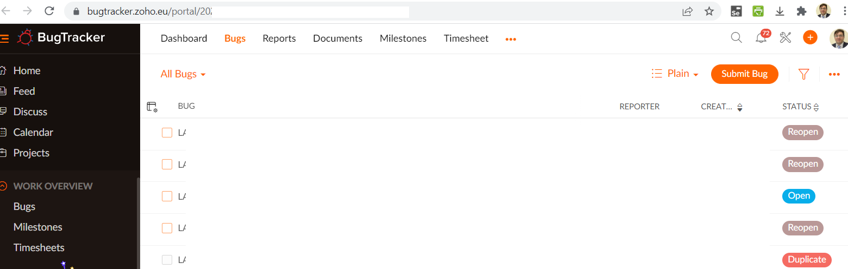

Important: As you can see below, and as instructed in the lab document, bug reports should have different status values and, thus, students should take their screenshot when there was a mix of all status values in their list.

Note: The screenshots of bugs in the report are the main approach for the teaching team to grade your bug reports.

### Screenshots of five randomly-selected bug reports in Zoho, reported by student A

#### Bug report 1:

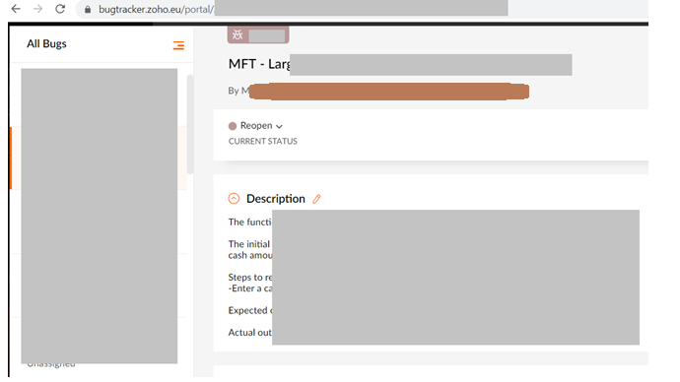

#### Bug report 2:



#### Bug report 3:

…

#### Bug report 4:

…

#### Bug report 5:

…

### Screenshots of five randomly-selected bug reports in Zoho, reported by student B

#### Bug report 1:



#### Bug report 2:



#### Bug report 3:

…

#### Bug report 4:

…

#### Bug report 5:

…

# Reporting from the exploratory testing

## Exploratory testing plan

Each team member should first document her/his test plan (see below). The team members should then discuss their plans with each other and prepare and document a single test plan for the team, as shown below.

### Exploratory testing plan, designed by student A

### Exploratory testing plan, designed by student B

## Your overall experience from exploratory testing

Write 200-300 words about your team’s overall experience from exploratory testing. Use explicit examples from your lab work

## Peer reviews of defect reports and duplicate bug reports, after exploratory testing

### Peer reviews, done by student A, on the defect reports submitted by student B

Total number of bug reports found via exploratory testing, by the other student = x

Total number of bug reports reviewed = x / 2

Text…

|  |  |  |  |  |  |  |  |  |  |
| --- | --- | --- | --- | --- | --- | --- | --- | --- | --- |
|  | Peer-review checklist criteria | | | | | | | |  |
| **Bug ID** | **1** | **2** | **3** | **4** | **5** | **6** | **7** | **8** | **Comment entered in the bug repository?** |
|  | √ x |  |  |  |  |  |  |  |  |
|  |  |  |  |  |  |  |  |  |  |

A few examples of the student’s peer-review comments on the other student’s bug reports:

…

### Peer reviews, done by student B, on the defect reports submitted by student A

Total number of bug reports found via exploratory testing, by the other student = x

Total number of bug reports reviewed = x / 2

Text…

|  |  |  |  |  |  |  |  |  |  |
| --- | --- | --- | --- | --- | --- | --- | --- | --- | --- |
|  | Peer-review checklist criteria | | | | | | | |  |
| **Bug ID** | **1** | **2** | **3** | **4** | **5** | **6** | **7** | **8** | **Comment entered in the bug repository?** |
|  | √ x |  |  |  |  |  |  |  |  |
|  |  |  |  |  |  |  |  |  |  |

A few examples of the student’s peer-review comments on the other student’s bug reports:

….

### Group’s learning and overall observation on peer-reviewing of bug reports

Text…

## A brief discussion of duplicate bug reports

Provide the ratio (%) of duplicate bug reports and a brief discussion…

# Manual scripted testing

Write 200-300 words about your team’s overall experience with manual scripted testing. Use explicit examples from your lab work

# Comparison of exploratory and manual-scripted functional testing in your lab work

By using explicit examples from your lab work, compare exploratory testing versus manual scripted functional testing w.r.t. the following aspects:

## Benefits (advantages) of each approach

* Using explicit examples from your lab work, compare the two approaches in your own words

## Drawbacks (disadvantages) of each approach

* Using explicit examples from your lab work, compare the two approaches in your own words

## Test effectiveness of each approach

* Using explicit examples from your lab work, compare the two approaches in your own words

## Test efficiency of each approach

* Using explicit examples from your lab work, compare the two approaches in your own words

## Trade-offs of the two approaches

* Using explicit examples from your lab work, compare the two approaches in your own words

# Regression testing (verification of defect fixes)

Write about 500 words about your team’s overall experience with regression testing. Use explicit examples from your lab work

Also discuss briefly your experience with regression testing in terms of the “Defect lifecycle” provided in Appendix A.

# Chain of software dependability threats: Error, defect, failure and incident

Recall the concepts of error, defect, failure and incident, that we have learned in the lectures. Take as an example one failure that you have found in your testing activities in this SUT, and then draw a visual cause-effect diagram in the format of what we have learned (also shown below). Explanation of each issue in the graph should be precise.



# Seven fundamental principles of Software Testing in the context of this testing project

Once you have finished all the lab-work, discuss in this section the seven fundamental principles of software testing (learned in the lectures) in the context of this testing project. Use explicit examples from your lab work

# Retrospective

## How the pair testing was managed and teamwork/effort was divided

### How the teamwork/effort of the lab was managed and divided

* You can say for example discuss which sections / parts of the lab was done by who…
* And also the meetings that you had to plan and run the lab work
* Etc.

### Writing the lab report

Fill up the following table to specify who wrote what part of the lab document:

|  |  |
| --- | --- |
| **Lab-report section** | **Written by** |
| 1- Introduction | Student A |
| 2-.. |  |
| … |  |

### Lessons learned from your teamwork in this lab

Only include lessons learned from **your teamwork in this section**. **“Technical”** lessons learned **shall be discussed in another section below.**

## Difficulties/ challenges encountered, overcoming them, and technical lessons learned

### Technical difficulties (challenges) that you encountered in this practical exercise

Text…

### How did you overcome the above difficulties and challenges?

Text…

### “Technical” Lessons learned

Only include **“technical”** lessons learned from **in this section**. Lessons learned **your “teamwork” shall be discussed in another section above.**

## Comments/feedback on the lab and lab document itself

This section has the following sub-sections.

### How did you handle time management? Was the provided time budget enough for this lab work?

Text…

### To what extent was the practical (laboratory) document clear, and easy to follow?

Text…

### If you have any comments for improvement of this laboratory exercise, provide them here

Text…